Socioeconomic Patterns in Diabetes Risk Report

Analysis of Diabetes Risk Factors and Predictive Modeling

This CSV file, provided to us by Pascal Wallisch in the class Principles of Data Science II, contains 253,680 entries and 22 variables covering medical, behavioral, and demographic information. The dataset allows for a detailed analysis of how socioeconomic factors relate to diabetes prevalence. The findings show clear socioeconomic differences in diabetes rates, with noticeable patterns across income and education levels that offer meaningful insight into the social factors that influence health.

The dataset shows a distinct class distribution, with 13.9% of individuals having diabetes and 86.1% not affected. This level of prevalence makes the dataset well-suited for studying risk factors and trends linked to the condition. The data is complete, with no missing values, and all values are in integer format, allowing a smooth analysis without extensive preprocessing.

Income as a Critical Determinant of Diabetes Prevalence
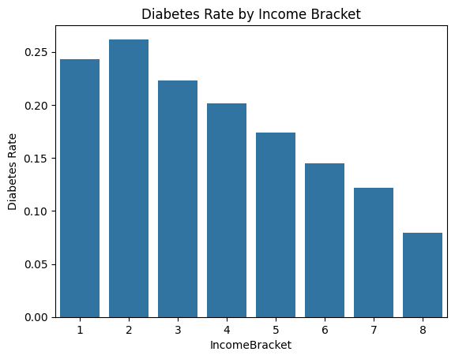
Our analysis shows a clear inverse relationship between income level and diabetes rates. Individuals in the lowest income brackets have much higher diabetes rates compared to those in higher income groups. The data shows that income bracket 1 has a diabetes rate of 24.29%, and bracket 2 has an even higher rate of 26.19%, making these the most at-risk groups. As income increases, diabetes prevalence steadily declines, with bracket 8 showing a rate of 7.96%. This difference between the highest and lowest income groups highlights how lower socioeconomic status can be a significant risk factor for diabetes.

|IncomeBracket|Diabetes|
|---|---|
|1|0\.2428906329630007|
|2|0\.2619027412373759|
|3|0\.22308365637113917|
|4|0\.20134094859697044|
|5|0\.17401383147239502|
|6|0\.1450781464217165|
|7|0\.12182142113422337|
|8|0\.0796039165790784|

Education Level as a Complementary Socioeconomic Factor
Education level shows a strong relationship with diabetes prevalence, similar to income. Individuals with lower educational attainment have higher diabetes rates, with education bracket 2 showing the highest prevalence at 29.26%, followed by bracket 1 at 27.01%. The peak at bracket 2 rather than bracket 1 suggests there may be nonlinear patterns or specific risks at moderate education levels that could be explored further. At the highest education level, bracket 6, diabetes prevalence decreases to 9.69%, indicating that higher education may serve as a protective factor.
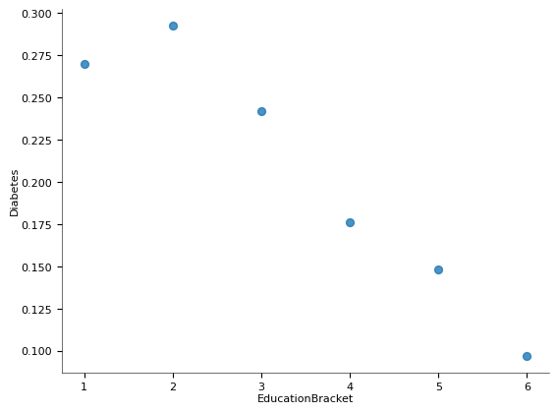
|EducationBracket|Diabetes|
|---|---|
|1|0\.27011494252873564|
|2|0\.29260450160771706|
|3|0\.24224519940915806|
|4|0\.17635059760956176|
|5|0\.14810470605063653|
|6|0\.0969019333799208|

BMI as a Mediating Factor in the Income-Diabetes Relationship
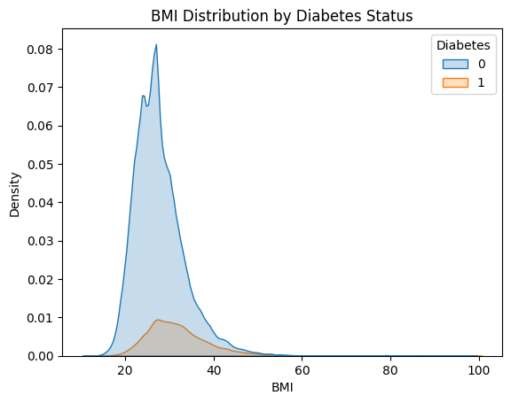
An interesting finding appears when looking at BMI in relation to income levels. The analysis shows that both BMI and diabetes rates decrease as income increases. Lower income brackets show higher diabetes rates as well as higher average BMIs, with income bracket 2 having the highest BMI at 29.76 along with its peak diabetes rate. Although diabetics and non-diabetics share a similar modal BMI, the BMI distribution for diabetics is right-skewed, meaning a larger share of diabetic individuals fall into higher BMI ranges. This pattern suggests that higher BMI in lower-income groups helps explain their elevated diabetes rates. The data also indicate that socioeconomic factors may influence diabetes risk partly through their impact on BMI, with lower income contributing to higher BMI and increased risk.

BMI | Diabetes
 | mean | mean
IncomeBracket
1 | 29.698094 | 0.242891
2 | 29.761181 | 0.261903
3 | 29.217394 | 0.223084
4 | 28.952818 | 0.201341
5 | 28.745238 | 0.174014
6 | 28.625418 | 0.145078
7 | 28.405424 | 0.121821
8 | 27.571942 | 0.079604

The Combined Impact of Income and Education
The heatmap analysis gives a clear view of how income and education interact to shape diabetes risk. The visualization shows that individuals with both low income and low education have the highest diabetes rates (top left of the heatmap). In contrast, those with high income and high education have the lowest rates (bottom right of the heatmap). The gradient pattern highlights that these factors work together rather than independently, with the most severe disadvantages occurring when multiple socioeconomic vulnerabilities overlap.
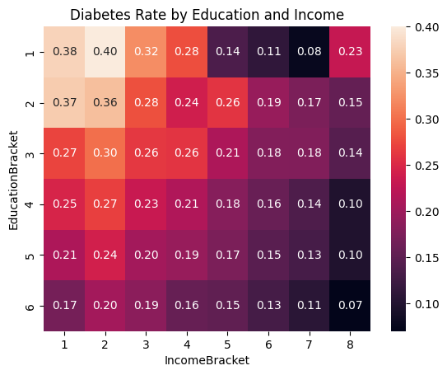
The Role of Affordability in Diabetes Risk
The affordability heatmap analysis shows how healthcare access and the ability to afford medical care work together to influence diabetes prevalence. Individuals who have healthcare coverage but cannot afford a doctor experience the highest diabetes rates, showing that insurance alone does not guarantee access to needed care. In contrast, those without coverage who can still afford a doctor have the lowest diabetes prevalence, highlighting the protective role of financial accessibility. The remaining groups, those with coverage who can afford care and those without coverage who cannot, show intermediate rates around 0.14, indicating moderate risk.
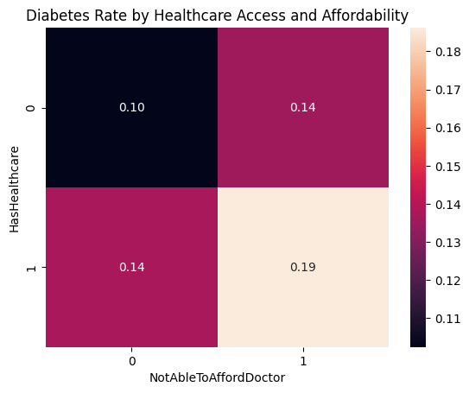

Socioeconomic Logistic Regression
The logistic regression model that uses only socioeconomic features reached an accuracy of 0.86, which suggests it classifies most individuals correctly. However, this number is misleading because the dataset is highly imbalanced, with far more non-diabetic than diabetic individuals. Class-specific metrics show the model’s limitations. Precision for the diabetes class is 0.41, recall is 0.00, and the F1-score is 0.01. These results show that although some positive predictions are correct, the model fails to identify nearly all actual diabetes cases.
The confusion matrix highlights this issue, as the model correctly predicts 43,632 non-diabetic individuals (true negatives) but identifies only 24 diabetics (true positives), missing 7,045 cases (false negatives). Only 35 non-diabetics are incorrectly classified as diabetic (false positives). The socioeconomic-only model is strongly biased toward the majority class and is ineffective at detecting diabetes, which shows the need for additional health and lifestyle features to improve performance.

Accuracy: 0.8604541154210028
precision recall f1-score support

0 0.86 1.00 0.92 43667
1 0.41 0.00 0.01 7069

accuracy 0.86 50736
macro avg 0.63 0.50 0.47 50736
weighted avg 0.80 0.86 0.80 50736

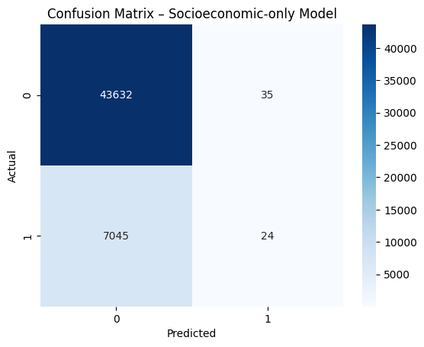
Full Feature Logistic Regression
The full-features logistic regression model reaches a similar accuracy of 0.86 as the socioeconomic-only model, but it performs much better at identifying individuals with diabetes. The class-specific metrics show this improvement clearly. Precision for the diabetes class increases to 0.52, recall rises to 0.16, and the F1-score improves to 0.24. These results show that the model can now correctly identify a meaningful share of individuals with diabetes and maintains a better balance between precision and recall.
The confusion matrix further highlights this progress, with true positives increasing from 24 to 1,122 and false negatives decreasing from 7,045 to 5,947. True negatives remain high at 42,628, while false positives increase from 35 to 1,039, showing that the model is more willing to predict diabetes even when it may be incorrect. Adding health and lifestyle features greatly strengthens the model’s ability to detect diabetes, reducing its earlier bias toward the majority class and creating a more useful tool for identifying at-risk individuals.

Accuracy: 0.8623068432671082
precision recall f1-score support

0 0.88 0.98 0.92 43667
1 0.52 0.16 0.24 7069

accuracy 0.86 50736
macro avg 0.70 0.57 0.58 50736
weighted avg 0.83 0.86 0.83 50736
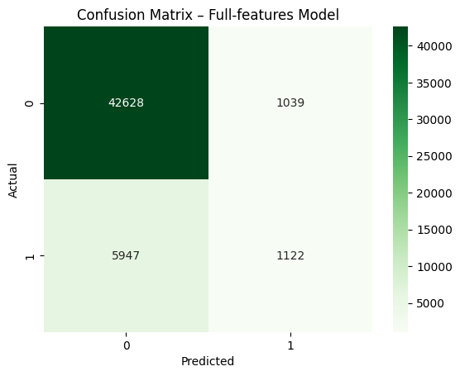

Logistic Coefficients
The analysis of the model coefficients shows a clear shift in what drives diabetes risk when moving from a socioeconomic-only model to a full-features model. In the socioeconomic-only model, the strongest predictors are biological sex, age, and barriers to healthcare access, showing how demographic and access-related factors relate to diabetes. When health and lifestyle variables are added, clinical measures become the dominant predictors. High blood pressure, high cholesterol, poor self-reported health, and elevated BMI are the most influential factors, while socioeconomic variables play a much smaller role. This shift suggests that the effects of income, education, and healthcare access on diabetes risk are largely shaped by underlying health conditions and behaviors, highlighting the importance of physiological and lifestyle factors in predicting diabetes outcomes.
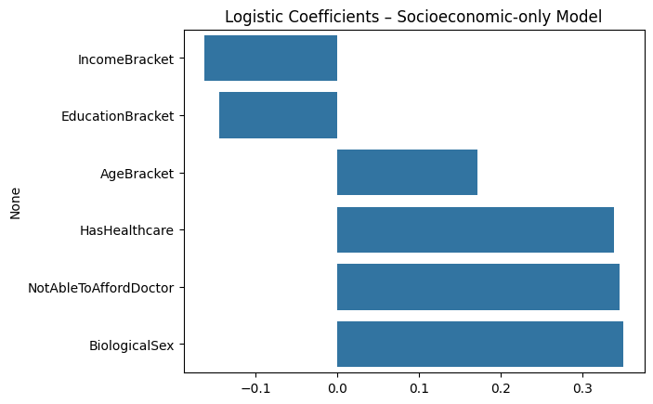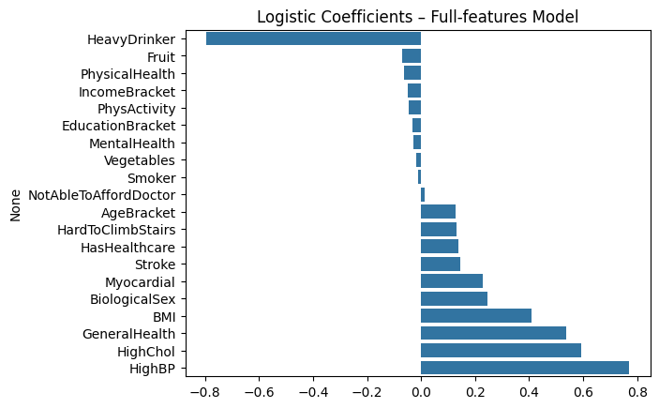

Findings
While socioeconomic factors alone cannot reliably predict whether an individual will develop diabetes, our research shows clear trends at the population level. Individuals with lower income and education have higher diabetes prevalence, likely influenced by higher BMI, limited healthcare access, and financial barriers that restrict preventive care. In contrast, higher-income and higher-education groups experience lower diabetes rates, reflecting the protective effects of greater resources, better access to care, and stronger health literacy. These findings highlight the important role of socioeconomic conditions in shaping diabetes risk at a broad level and emphasize the value of targeted efforts focused on improving education, affordability, and healthcare access to help reduce disparities and support better health outcomes.

Recommendations
Based on the patterns observed in our analysis, several steps could help reduce disparities in diabetes risk across different socioeconomic groups. Increasing access to health education, particularly in lower-income and lower-education communities, may support earlier prevention and better long-term health decisions. Improving the affordability of healthcare services is also important, since individuals who cannot pay for care experience higher diabetes prevalence even when they have insurance. Community programs that promote physical activity and healthier eating habits may help address high BMI levels, which strongly relate to diabetes risk. Finally, public health efforts that focus on reducing financial and informational barriers could play a key role in lowering diabetes rates and supporting individuals who face a higher burden of risk.

